|  |  |
| --- | --- |
| **Course Code: CSL402** | **Course Name: Database Management System Lab** |
| **Class: SE-CO** | **Batch: 2020-24** |
| **Roll no: 20CO24** | **Name: Khan Arshad Abdulla** |

**Experiment: 06**

**Aim: Perform Join Operations.**

**Case Study Title – Currency Converter**

**Theory:**

**Joins**

Natural Join

The natural join of two tables R and S is obtained by applying a selection and a projection to the Cartesian Product R x S as follows;

1. For each column ‘a’ that is common to both tables R and S, we select rows that satisfy the condition R.a = S.a
2. For each column ‘a’ that is common to both tables R and S, we project out the column S.a. There if there are ‘m’ columns common to both tables, ‘m’ duplicate columns are removed from the Cartesian product.

Natural join command finds matching rows from the two tables that are being joined and reject rows that do not match.

A JOIN clause is used to combine rows from two or more tables, based on a related column between them.

The INNER JOIN keyword selects records that have matching values in both tables.

Syntax:

SELECT column_name(s)

FROM table1

INNER JOIN table2 ON table1.column_name = table2.column_name;

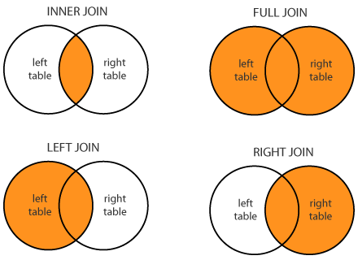

Left Join

The LEFT JOIN keyword returns all records from the left table (table1), and the matched records from the right table (table2). The result is NULL from the right side, if there is no match.

Syntax : SELECT column_name(s)

FROM table1

LEFT JOIN table2 ON table1.column_name = table2.column_name;

Right Join

The RIGHT JOIN keyword returns all records from the right table (table2), and the matched records from the left table (table1). The result is NULL from the left side, when there is no match.

Syntax:

SELECT column_name(s)

FROM table1

RIGHT JOIN table2 ON table1.column_name = table2.column_name;

Full Join

The FULL OUTER JOIN keyword return all records when there is a match in either left (table1) or right (table2) table records.

Syntax:

SELECT column_name(s)

FROM table1

LEFT JOIN table2 ON table1.column_name = table2.column_name

UNION

SELECT column_name(s)

FROM table1

RIGHT JOIN table2 ON table1.column_name = table2.column_name;

Q4. **Inner join / Join**

select Player.PlayerID, Player.Fname, Player.Lname, Batting.NRuns, Batting.Fours, Batting.Six from Player join Batting ON Player.PlayerID = Batting.PID;

Q5. **Left Join**

select Player.PlayerID, Player.Fname, Player.Lname, Batting.NRuns, Batting.Fours, Batting.Six from Player left join Batting ON Player.PlayerID = Batting.PID;

Q6. **Right Join**

select Player.PlayerID, Player.Fname, Player.Lname, Batting.NRuns,g.Fours, Batting.Six from Player right join Batting ON Player.PlayerID = Batting.PID;

Q7. **Outer Join**

select Player.PlayerID, Player.Fname, Player.Lname, Batting.NRuns, Batting.Fours, Batting.Six from Player left join Batting ON Player.PlayerID = Batting.PID

-> UNION

-> select Player.PlayerID, Player.Fname, Player.Lname, Batting.NRuns, Batting.Fours, Batting.Six from Player right join Batting ON Player.PlayerID = Batting.PID;

**Output:**

**Attach the output of the join operations on your project in txt format.**

**Conclusion:**

|  |
| --- |
| In this experiment we have successfully implemented join operations. I understood how to join two tables using common column of both tables. |